Pitcher Plans
This is a practice that can be done on the field as well as off. The goal is to obtain mental readiness so the player can execute their plan without thinking during execution. Remember CPT:
Control – Am I in my ready position? Glove on, standing in right area…
Plan – What’s my play if I get the ball; plan the play before it happens, have a backup plan; if I drop the ball then what?
Trust – Trust! Trust that you will execute your plan because you’ve already gone over it in your head.
Mental Checklist
- Control: Am I in my ready position?
- Plan: If I get the ball. Picther strategies
NOTE: Before every pitch, make sure you know who’s on base. You never know when you’ll be part of the play.
RUNNERS ON | PLAN | BACKUP PLAN
None | Throw/toss to 1B. | Possible throw to 2nd base if runner continues.
1st | Throw/toss to 1B. | Possible throw to 2nd or 3rd base if runners continue.
1st, 2nd | Throw/toss to 1B. | Possible throw to home depending on if runners continue.
1st, 2nd, 3rd | Depends on where the ball is. Most often, go 1B. If you are fielding in towards home, throw/toss to home. | Go to home to defend base to tag runners that continue.
2nd | Throw/toss to 1B. | Hold ball and possible throw to 3rd base if 2nd base runner goes.
2nd, 3rd | Throw/toss to 1B. | Go to home to defend base to tag runners that continue.
1st, 3rd | Throw/toss to 1B. | Go to home to defend base to tag runners that continue.

- Trust!

Mastering the easy outs is a good place to start since they take less strategy. Planning the play can be done on the field and off. As a mental exercise, you can run through plays with your child in the car, on the way home from school or at home for a few minutes. The more mental repetitions they have of thinking the play the chances are higher they will execute the play without thinking once presented with the situation.

Bunts
If the batter is bunting or does a delay bunt, you will cover the ball near you or on the 1st base side. Usually get the out at 1B in this situation.

Pick Offs: 1st Base
If the is a runner only on 1st base, you can consider picking him off if he is taking too much of a lead. Do not try to pick the same runner off more than twice if at all once. You don’t want them knowing your timing or getting a free base.
- Wind up pick off (ONLY FOR LEFT HANDERS): If you already plan to pick the runner off, you can go into your wind up slowly, and either continue your motion to 1st base or partially deliver your stretch staying within 45 degrees of rubber to throw to first. This is very powerful for a LEFT handed pitcher. Another reason why you NEVER rush the windup into the pitch.
- Off the rubber: If you know you already plan to pick the runner off, you can remove the foot off the rubber and throw to 1B base.
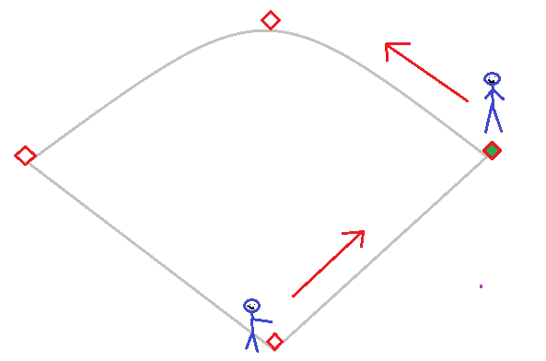
Pick Offs: 2nd Base
If runners are in either of the following pictures, if he’s leading off too much consider picking him off. Do not try to pick the same runner off more than twice if at all once. You don’t want them knowing your timing.
- Wind up pick off: If you already plan to pick the runner off, you can go into your wind up slowly then at the last minute continue your motion towards throwing to 2nd. This will catch the runner off guard. Another reason why you NEVER rush the windup into the pitch.
- Off the rubber: If you know you already plan to pick the runner off, you can remove the foot off the rubber and throw to 2nd base.
